PAGES INVOLED

HOME PAGE
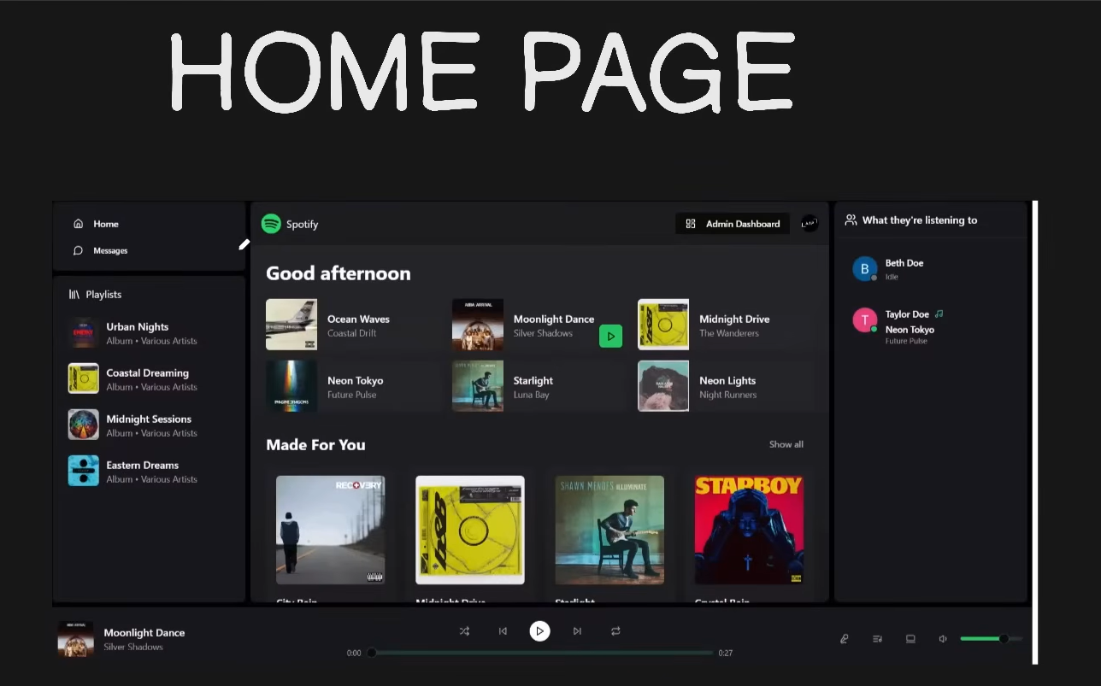

CHAT PAGE
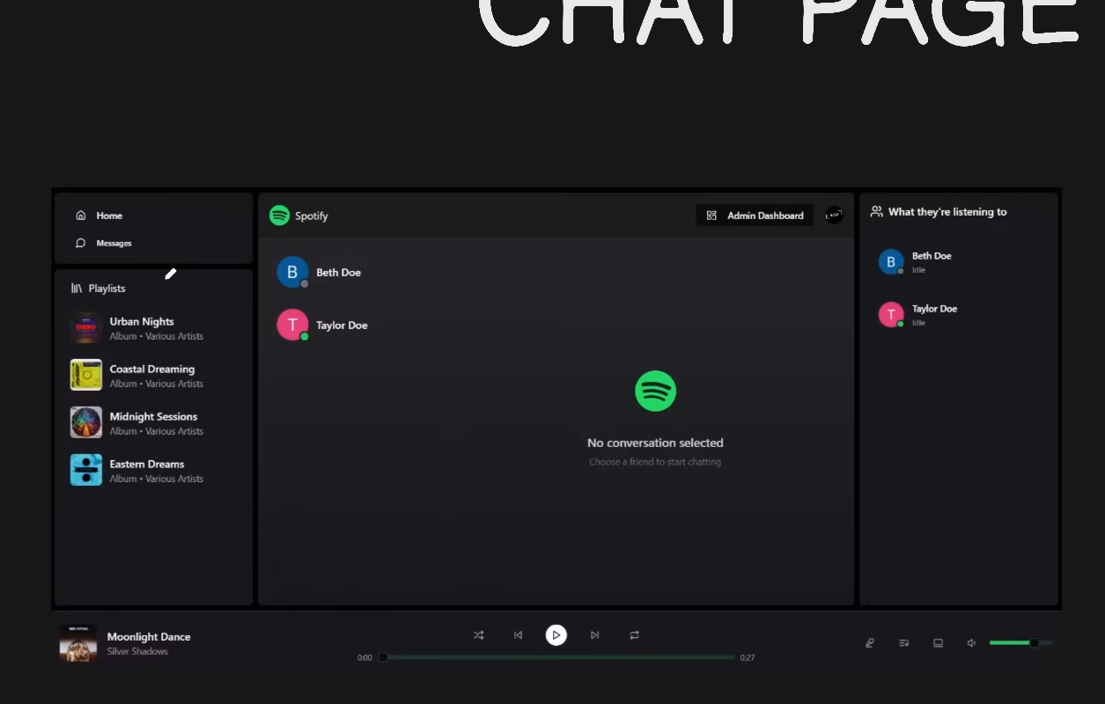

ALBUM PAGE
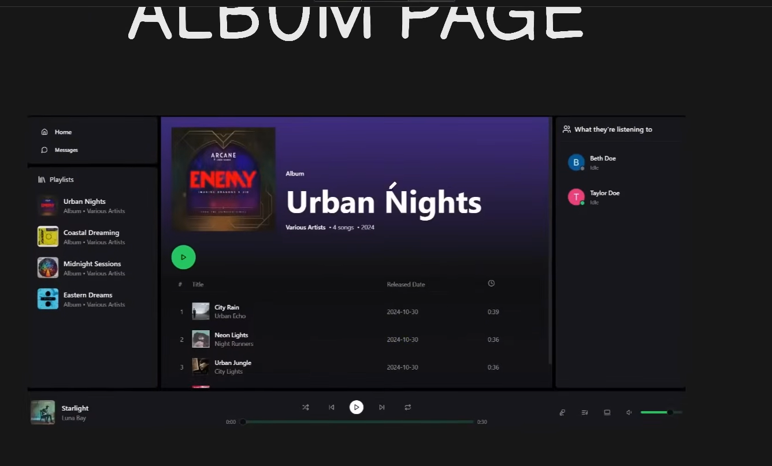

ADMIN PAGE(ADD SONGS)
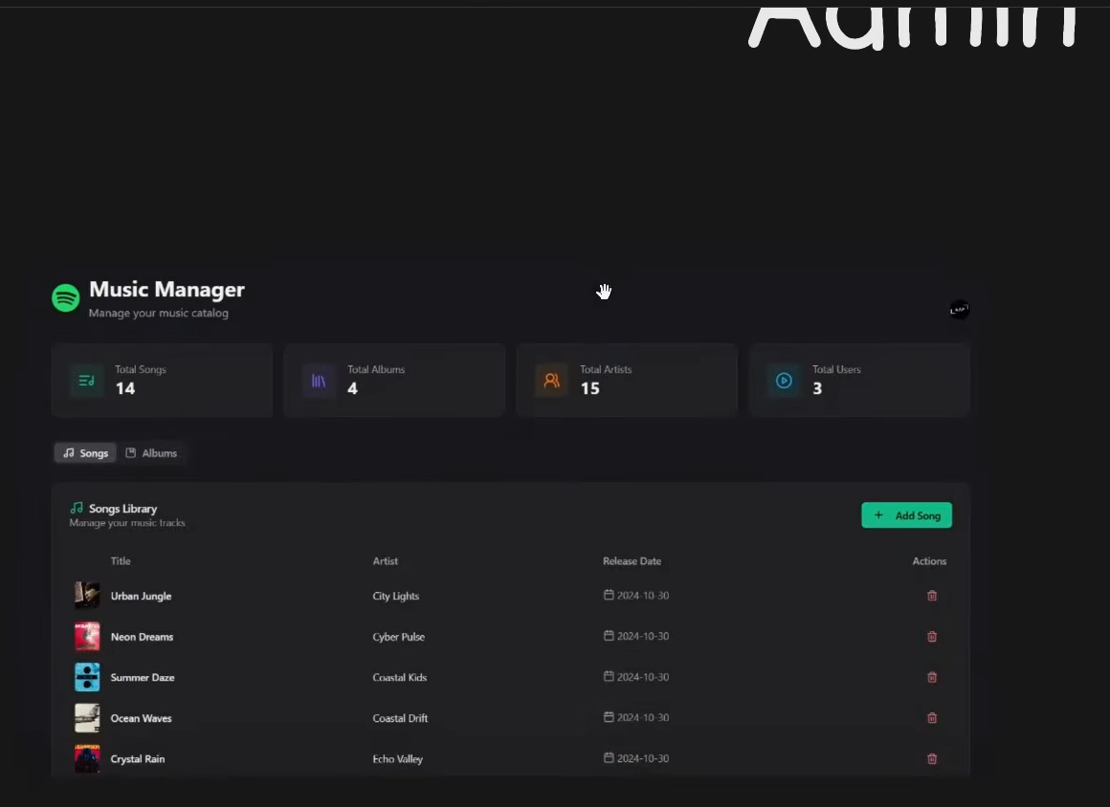

ADMIN PAGE(ADD ALBUMS TO THE RIGHT)
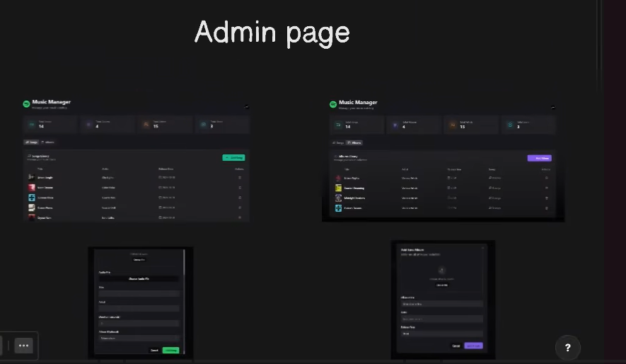

Auth callback page
